**Homework Lesson 16**

**Angelika Kryvoruchenko**

Level 1 :

**1.Shop By Brand carousel has inconsistent text size**

**Description**: The carousel in shop by brand has text which looks out of place in relation to the rest of the text of the page

**Steps to reproduce:**

Go to website [www.petsmart.com](http://www.petsmart.com)

Click Shop by brand

**Expected result:**

The text should comparable with the product text

**Actual result:**

The text from a user perspective is too big compared to the product text below it.

**Severity:** 3

**Priority:** 2

**Environment:** IOS

**2.Filter Dropdown causes redirect to a blank page**

**Description**: When a user clicks on the filter dropdown the page seems to go blank

**Steps to reproduce:**

1.Go to website [www.petsmart.com](http://www.petsmart.com)

2.Click Shop by brand

3.Scroll to the end of the page and click the Filter dropdown

**Expected result:**

The user should be presented with a dropdown of items

**Actual result:**

The user is presented with a blank page

**Severity:** 2

**Priority:** 2

**Environment:** IOS

**3.Add to cart button briefly changes to error status label on click**

**Description**: When a user clicks on the add to cart button an error appears on the button label

**Steps to reproduce:**

1.Go to website [www.petsmart.com](http://www.petsmart.com)

2.Click Deals

3.Select all deals

4. Select any product

5. Click add to cart

**Expected result:**

The Product should appear at the cart

**Actual result:**

The error appears

**Severity:**1

**Priority:**1

**Environment:** IOS

**4. Login button shows spinner status after click**

**Description**: When a user clicks on a login button having entered invalid details they are presented with a spinner which does not disappear

**Steps to reproduce:**

1.Go to website [www.petsmart.com](http://www.petsmart.com)

2.Click Login

3. Enter invalid email and password

4. Click Login button

**Expected result:**

A user should be presented with only an error regarding invalid details entered

**Actual result:**

A user is presented with an error and the login button turns to a spinner

**Severity:** 3

**Priority:** 2

**Environment:** IOS

**5.Filter does not work on search results**

**Description**: Searching for an item and then trying to use the filter functionality causes unexpected results

**Steps to reproduce:**

1.Go to website [www.petsmart.com](http://www.petsmart.com)

2.Enter a search term, such as” pig”

3. Select the filter

**Expected result:**

Filter should display options

**Actual result:**

The user gets redirected to a different page

**Severity:** 2

**Priority:** 2

**Environment:** IOS

Level 2

Websites are not loading on emulator

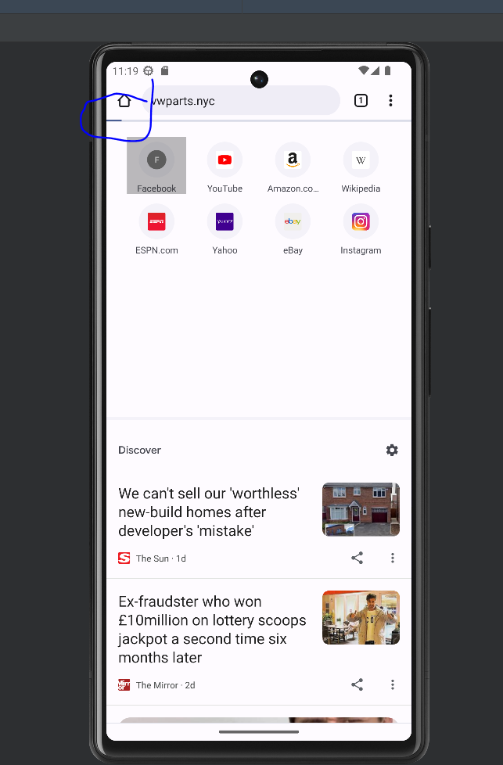

Level 3

**API Testing**

1. Ensure users list endpoint works
2. Verify post API sends data
3. Ensure like API endpoint works
4. Test comment endpoint adds data
5. Verify user details endpoint retrieves data

**System Testing**

1. Test that a user can post a message
2. Test that a user can like a post
3. Test that a user can view other posters details
4. Test that a user can read messages
5. Test that a user can delete posts

**Integration Testing**

1. Verify delete operation removes data
2. Verify posting photos saves data
3. Verify editing profile information updates data
4. Verify comments are preserved
5. Verify send post to other users works

**Instal\ Uninstal testing**

1. Verify app can be installed
2. Verify correct operation after install
3. Verify app can be uninstalled
4. Verify app data is deleted after uninstall
5. Verify app links are completely removed from device after uninstall